Lab Sheet: Hypothesis Testing with R
Objective: To learn how to construct interval estimates and perform hypothesis tests for single and multiple samples using R programming.

1. Understanding Decision Criteria (3 Minutes)
Before executing tests, you must determine how to interpret the results using one of two primary methods:
- Traditional (Critical Region) Method: Identify the critical region; if the test statistic falls within this region, you reject H0.
- P-value Method: Define a significance level (α); if the P-value ≤α, you reject H0.
- Note: If the P-value is greater than α, you fail to reject H0.
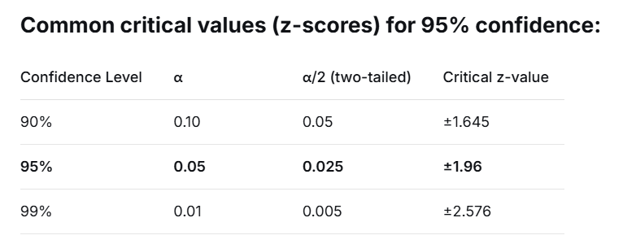

2. Interval Estimation (7 Minutes)
Interval estimation provides a range of values within which a population parameter is expected to fall with a certain level of confidence.

For Proportions:
- Reference File: lectureFIVE-ONE #01.


- You can use the manual calculation or
n = 594
k = 192
pbar = n/k;
se = sqrt(pbar*(1-pbar)/n)
cv = qnorm(0.975)
errmargin = se*cv;
#Get the interval
10 pbar+c(-errmargin,errmargin)

- The built-in prop.test() function, which defaults to a 95% confidence interval.
n = 594; k = 192
prop.test(k, n) #Displays p-estimate and confidence interval

For Means (Known Variance):
- Reference File: lectureFIVE-ONE #02.


# Example: Estimating mean demand for 25 time periods
n = 25; stdDev = 75; x = c(235, 374, 309, 499, 253, 421, 361, 514, 462, 369, 394, 439, 348, 344, 330, 261, 374, 302, 466, 535, 386, 316, 296, 332, 334)
xbar = mean(x); se = stdDev/sqrt(n)
cv = qnorm(0.975) #Get Z critical value
errmargin = cv * se
xbar + c(-errmargin, errmargin) #Calculate lower and upper limits

3. One-Sample Hypothesis Testing (10 Minutes)
These tests compare a sample statistic against a known population parameter.

Test on Proportion (One-Tailed):
- Reference Example: Testing if current voting proportion is below 60%.
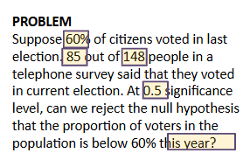
n = 148; k = 85; p = 0.6; pbar = k/n
z = (pbar - p) / sqrt(p * (1 - p) / n) #Z statistics
pval = pnorm(z) #Calculate p-value

Test on Mean (Known Variance):
- Reference File: lectureFIVE-TWO #02.
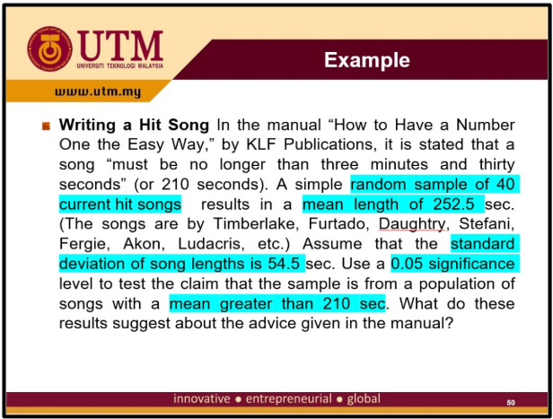
- One-tailed example:
# One-Tailed Example: Test if song length > 210 seconds
n = 40
sd = 54.5
xbar = 252.5
mu = 210
alpha = 0.05
z = (xbar - mu) / (sd / sqrt(n))
pval = pnorm(z, lower.tail = FALSE)

- Reference:
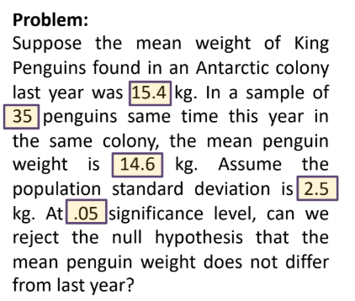
- For a two-tailed test, the p-value must multiply by 2.
#Two-Tailed Example: Test if mean penguin weight differ from last year
n = 35
sd = 2.5
xbar = 14.6
mu = 15.4
alpha = 0.05
#Calculate Z statistics
z = (xbar-mu)/(sd/sqrt(n))
#Calculate p-value for Z
pval = 2*pnorm(z)

Test on Mean (Unknown Variance):
- Use the T-distribution functions qt() for critical values and pt() to get the P-values for T statistics.


#One-Tailed Example: Test if population mean exceeds 0.82
x = c(0.8411, 0.8191, 0.8182, 0.8125,0.8750, 0.8580, 0.8532, 0.8483,0.8276, 0.7983, 0.8042, 0.8730,0.8282, 0.8359, 0.8660)
n = 15
s = sd(x)
xbar = mean(x)
mu = 0.82

#Calculate t statistics
t = (xbar-mu)/(s/sqrt(n))

#Calculate p-value of t
pval = pt(t, df=n-1,lower.tail=FALSE)

Test on Variance:
- Use qchisq() to calculate the Chi-square critical value based on significance level and degrees of freedom (n−1).
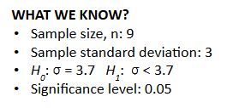
#Two-Tailed Example: Test if population variance less than 3.7
n = 9
s.sd = 3
sigma = 3.7
alpha = 0.05
#Calculate chi-square
x2 = ((n-1)*s.sd^2)/(sigma^2)
#Calculate critical value
x2.alpha = qchisq(alpha, df=n-1)

4. Two-Sample Hypothesis Testing (10 Minutes)
Used to compare parameters from two different populations.

Two Proportions (One-Tailed):
- Reference File: lectureFIVE-THREE #01.
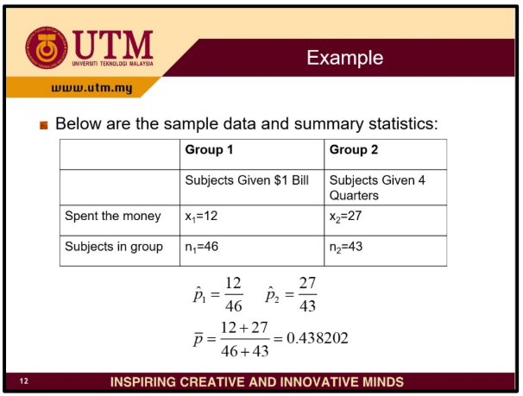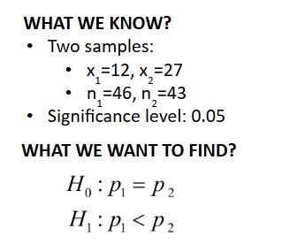

#Test if Group 1 spent less than Group 2
x1 = 12; x2 = 27; n1 = 46; n2 = 43
phat1 <- x1/n1
phat2 <- x2/n2
pbar = (x1+x2)/(n1+n2)
qbar = 1-pbar
z = ((phat1-phat2)-0)/sqrt((pbar*qbar/n1)+(pbar*qbar/n2))
alpha = 0.05
z.alpha = qnorm(alpha)

#alternative
prop.test(c(x1, x2), c(n1, n2), alternative = "less")

#If(z < z.alpha) or if p1 < p2, reject H0

Two Means (Known Variance):
- Reference File: lectureFIVE-THREE #02.

#Test if two paint formulation drying times are sig. diff.
xbar1 = 121; xbar2 = 112; n1 = 10; n2 = 10; sigma1 = 8; sigma2 = 8
variance1 = sigma1^2
variance2 = sigma2^2
z = ((xbar1-xbar2-0)/(sqrt((variance1/n1)+(variance2/n2))))
alpha = 0.05
z.alpha = qnorm(alpha,lower.tail=FALSE)
p_value = 2 * (1 - pnorm(abs(z)))
#If(abs(z) > z.alpha) or if p_value < alpha, reject H0

Two Means (Unknown Variance):
- Case 1 (Equal Variance): Pooled variance is used in the calculation.
- Case 2 (Unequal Variance): Requires calculating specific degrees of freedom (v) for the T-test.
Quick Reference Note: Always use # to comment your hypothesis statements (H0 and H1) in your script to keep your analysis organized.

